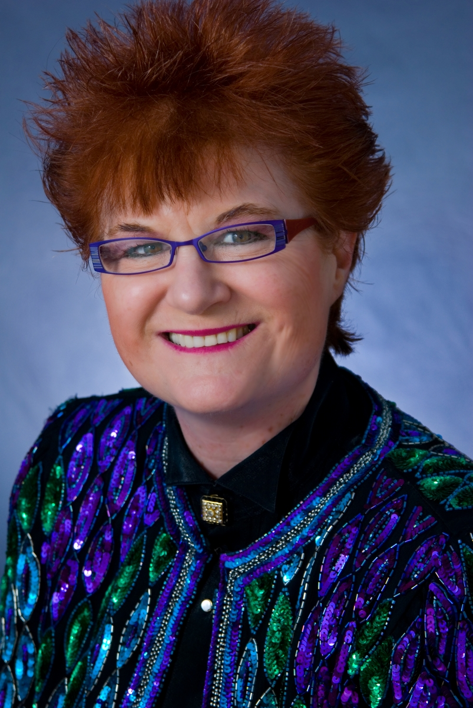

PRESS RELEASE FOR MAGIC JEANNE

Magic Jeanne will be performing at The Rhino Theater on
September 8th, 2007
3:00 show and 8:00 show

This magic show is for all age groups

In May of 1991 Magic was at work and was introduced to a Master Magician. He then performed some sleight of hand magic as a way of promoting a magic workshop. She attended. The purpose of the workshop was to see if your ability and interest was strong enough so that you could be taught the art of magic. She will tell you that she’s been entertaining all of her life in one way or another and now this would give her a professional venue that she could take even further. From that moment her life once again took a turn of learning and applying life experiences to her magic.

Over the years, Magic has entertained at the following types of affairs: Holiday Parties, Trade Shows, Conventions, Restaurants, Wedding receptions, Retirement parties, Anniversaries, Company gatherings, School Events, Bar mitzvahs, Bat mitzvahs, Communions, Birthday parties, Fund-raisers, Fairs, Picnics, Grand openings, Banquets, Festivals, Quincianeras, Cocktail parties and Family reunions.

Contact information for Magic Jeanne is:

www.magicjeanne.com
magicjeanne@sbcglobal.net
650-208-2741

