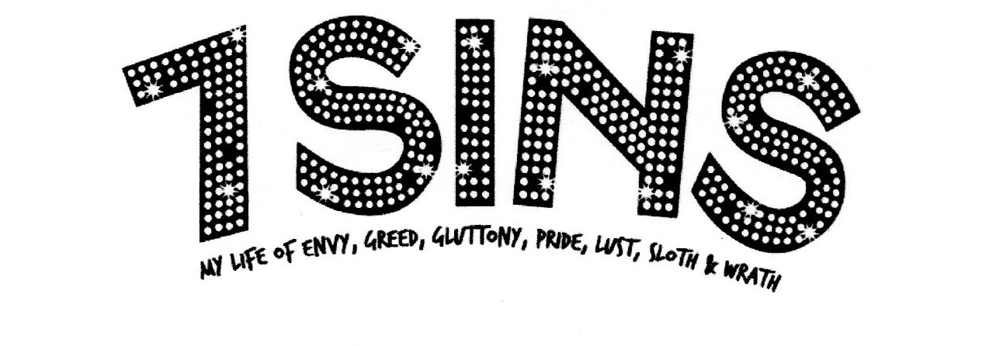

PRESS RELEASE

James Judd’s award-wining solo show 7 SINS will be performed Friday and Saturday nights at 8pm beginning April 4th at the Theatre Rhino Studio.

PRESS CONTACT: Dana Sundblad, 415-786-5657

The Toronto Star writes, “Judd is Paul Lynde for the new millennium. His show is off-the-wall and out-of-the-ballpark entertaining. To miss it would be the eighth and deadliest sin of all.” The Rochester Democrat & Chronicle says, “He’s David Sedaris on a pot of coffee.” The Winnipeg Sun writes, “Judd’s jokes are hyper-funny, making the show a witty, sophisticated breeze.”

7 SINS is a collection of true, fast, and funny stories from the life of writer/comedian James Judd. It chronicles his early ambition to win his 5th Grade book report competition with My Search for Patty Hearst, and his first job when his working mother paid him to watch The Young and the Restless and then reenact it for her. He relives his varied careers as a forgotten employee of AT&T, where he did nothing for a year, an even shorter-lived career as a dot.com journalist (which led to an insane night with five Chinese billionaires in a Chinese bordello), and as an under-prepared criminal defense attorney representing violent teenage girls, as well as many more strange and always funny stories.

7 SINS is NOT poignant! It ‘s NOT inspirational! It’s just 75 minutes of FUNNY!

7 SINS began as a local group show. The SF Weekly said, “It was the funniest night I’d had all year.” Judd made a solo show for the Canadian Fringe Festival Circuit out of the stories he’d honed from the SF group show. It set several new fringe festival attendance records for a solo show over the course of more than 100 performances. It also won the London, Ontario Theater Guild’s prestigious Brickenden Award for Outstanding International Production, and it also received numerous “Best of Fringe”, “Best Solo Performance”, and “Audience Favorite” accolades . A complete set of reviews is included in the press kit to follow.

James Judd grew up in Saratoga, California and began his training at A.C.T.’s Young Conservatory Summer Program. He is a graduate of the University of San Francisco. He has performed in the SF Comedy Competition, Star Search, Evening at the Improv and was a member of the Groundlings Theater in Los Angeles. He lives in San Francisco.

7 SINS will be performed this year at the Edinburgh Festival, produced by Fringe Management International. Randall Rapstine, who recently directed Margaret Cho’s electrifying revue The Sensuous Woman at the Zipper Factory off-Broadway, is helming the production.

Tickets for 7 SINS are just $10. FREE tickets are available at the door if you are God, Jesus, any internationally recognized deity, a saint in the mind of two or more full price ticket buyers accompanying you, or you are able to “cast the first stone.” (Note: ability to cast the first stone requires proof. Also note, rocks are not permitted in the theater.)

