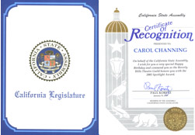
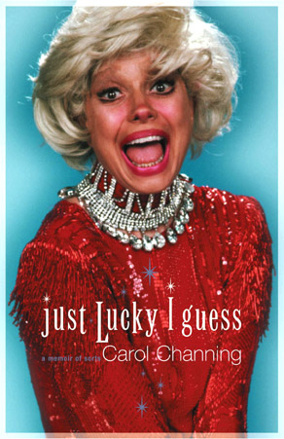
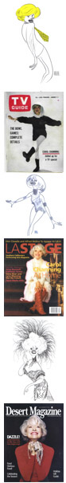

DR. CAROL CHANNING AND THE HARRY KULLIJIAN
ENDOWMENT FOR THE ARTS

MISSION - Education in public schools of California to reestablish Art as a pre-requisite not an option, inclusive at all levels and grades.

The continual decline in our cultural bonds within communities stretching from Oregon to Mexico, can be traced in part to the lack of attention on the Arts in public education. Studies have conclusively provided the statistical information that students with an art education are better students overall.

Arts in Education enhances the abilities of learning from a very early age. It provides a sensitive relationship for our youth regardless of the form of Art. Reading, writing, communicating, observing, being inspired by, creativity in action, the list is endless.

QUESTION- Why or How has this unintended education-cultural (Fine Arts) tool been allowed to erode? The Arts has many detractors. However, modern electronics has changed the vision and priorities of the world. Choices of so-called art and entertainment are so numerous they are without number.

IS IT POSSIBLE TO RESTORE?— The classic arts will be with us always. If you can accept this last statement as legitimate and true then the work of this foundation has begun

HOW CAN IT BE RESTORED?— When artists from every field of art, when educators and political entities, local and state, feel that the general public is willing to subscribe to Arts in Education or Education in the Arts, this effort will have taken a major step forward.

Carol Channing has joined with the largest University in the world. Chancellor Dr. Charles Reed, of the California State Universities, has provide access to the 23 university campuses located throughout the length and breath of California. Dr. Channing has volunteered to establish a scholarship at each school. She has agreed to provide a full length performance with university and/or high school students. Most of all, her desire is to teach and lecture the master classes. She feels that most importantly the general public be invited at little or no cost to witness the interplay, fascination and excitement generated between the master artist and the students.

Her dream is to come up with a support program which ensures that young students who show an aptitude for the arts have a college scholarship to help them build on those talents.
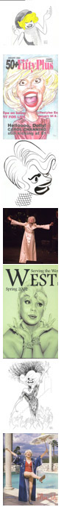

Carol Channing, famed actress, singer and Broadway star known as the “first lady of musical comedy,” is serious about the next phase of her long career that will be devoted to the arts in education. “Receiving the doctorate honor precipitated a deep interest in projecting that into a meaningful program through which I could elevate the arts in California, “ Carol said, “ "Our school children are the ones who will carry on and reinvigorate California’s fine and performing arts tradition."

A name that brings instant recognition worldwide. Ms Channing was the recipient of the 1995 Lifetime Achievement Tony Award, a stage career that has made her a star of international acclaim since her performance as Lorelei Lee in "Gentleman Prefer Blondes." The three time Tony, Golden Globe and Emmy award winning and Oscar nominated comedienne will forever be endeared to the hearts of audiences everywhere for a record breaking 5,000 performances as the irrepressible Dolly Levy in "Hello Dolly!" without missing a single performance. The octogenarian continues to enjoying a highly active schedule and with her new highly applauded one-woman show, entitled "The First Eighty Years are the Hardest."

Known for her humor, spirited warmth and good looks at the age of 85, Carol still delights in performing and making audiences laugh. She and her husband, Harry Kullijian, have launched a statewide, and what they hope will eventually become a national campaign, in support of fine and performing arts programs in the public schools system.

Kullijian said a number of other celebrities also have indicated an interest in joining a campaign to promote the arts. “We want to bring attention to other artists that they must get involved with the university systems to build more support for the fine and performing arts,” Kullijian said. “Hopefully, and ultimately, the children in grade schools and teenagers in high schools will be provided with the incentives to refocus on the fine arts through the influence of university communities” and the public who supports them.

Donations may be sent to the Channing - Kullijian Foundation. (Tax Deductible)

Channing-Kullijian Foundation
P.O. Box 990
Los Altos, CA 94023-0990
