CAROL CHANNING

Since her Broadway debut in Blitzsteins’ For An Answer and a Time Magazine cover story, which hailed her performance as Lorelei in Gentlemen Prefer Blondes, Miss Channing has been a star of international acclaim. Her Broadway appearances include some of the most memorable characters in theatrical history, winning three Tony Awards® including one for her legendary portrayal of Dolly Levi in Jerry Herman’s Hello, Dolly! as well as one for Lifetime Achievement. Carol’s career has been varied and continuing. During her first film role in The First Traveling Saleslady starring opposite Ginger Rogers, she also gave newcomer Clint Eastwood his first on screen kiss. Among her numerous TV and Film successes was the madcap Muzzy in Thoroughly Modern Millie, which earned her an Oscar nomination and a Golden Globe Award. In 2008, Carol was inducted into the Smithsonian Institute in D.C., along with eight other legendary ladies of stage and screen. She still performs with the gusto of a young aspiring actress and has recently committed her life to bringing a refocus on the Arts to the public
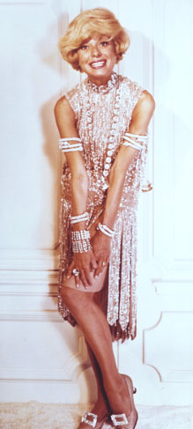
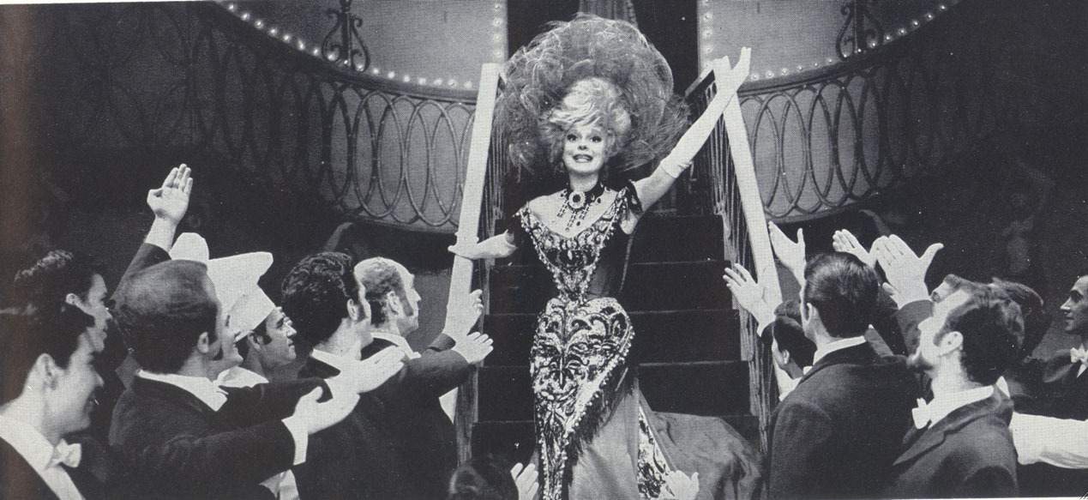
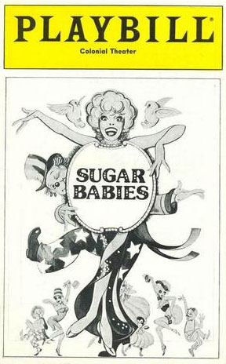
educational system. Through the Carol Channing/
Harry Kullijian Endowment for the Arts Foundation,
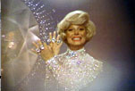
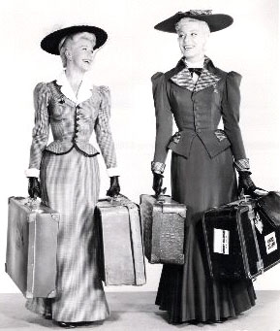
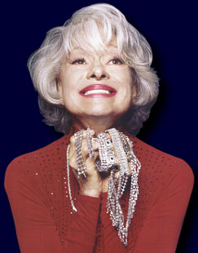
Carol offers lectures and performances, hoping to engage the public’s support for education in the Arts while also creating scholarships.

